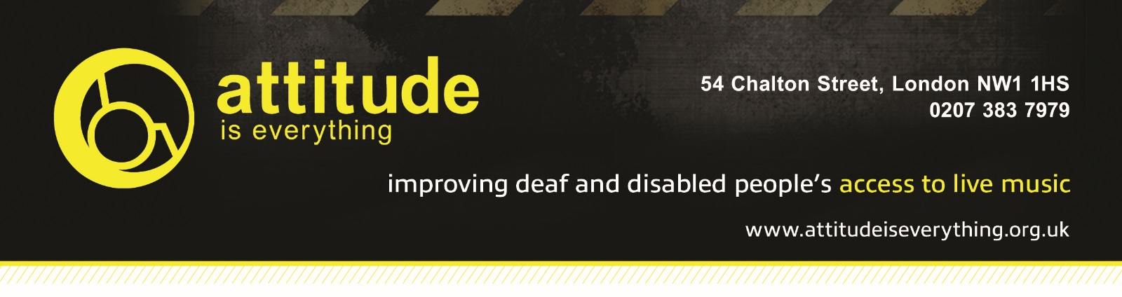

Access Starts Online – Venue Access Info Template

- Introduction
We’re committed to making performances accessible to everyone and are able to offer free carers tickets for events at The LCR and The Waterfront to patrons with disabilities. If the information you require is not listed below, then please get in touch via email on boxoffice@uea.ac.uk or by calling us on 01603 508050.

We work with Attitude is Everything specifically to improve Deaf and disabled people's access to live music by working in partnership with audiences, artists and the music industry. If you are interested in the work Attitude Is Everything does, then please visit their website to get involved or donate - www.attitudeiseverything.org.uk.

Please note we are unable to guarantee carers tickets for the other venues that we sell tickets on behalf of. Please contact that venue directly to discuss their policy.

- Contact Details
For all enquiries please contact boxoffice@uea.ac.uk or call UEA Box office on 01603 508050 or The Waterfront on 01603 632717.

- Download Link (word doc)
If you’d like to download this guide, please click here:
- Venue Description
There is step free access from the nearest car park on Rouen Road, however the route has a moderate to steep slope. Cars are able to stop directly outside the venue to drop off passengers.
The building comprises two floors. The ground floor contains a 700 capacity main room with integral bar and disabled toilets. There is step free access to all facilities. There is space either side of the stage that may be used by wheelchair users during concerts. Whilst we cannot guarantee that this will be free to use as a viewing area, we will do our best to accommodate any requirements. Please notify us in advance if a viewing area is desired as this will increase the likelihood that we can accommodate this. For Health & Safety reasons, wheelchairs cannot be situated in front of the stage barrier.

The first floor (The Waterfront Studio) is a 200 capacity room, and a café bar which is accessible via a flight of stairs. We advise that wheelchair users that are unable to be removed from their wheelchair not to purchase tickets, as there is currently no safe means of escape. The viewing area is all on one level and there is no designated space for wheelchair users however the view from the side of the room should be adequate.

- Bookable Access Facilities + How To Apply (if applicable)
Deaf and disabled customers, who would be unable to attend a gig without assistance, are entitled to a free ticket for their 'Personal Assistant/Companion'.
Please purchase one standard ticket. Once you have purchased a ticket, you should then contact us on boxoffice@uea.ac.uk with your booking reference and address. We will then post you a free ticket to be used by your 'Personal Assistant/Companion'.

Please note that our staff are not trained to lift or carry people who may need help or to assist with personal or medical needs. We provide a free personal assistant ticket in order that customers with these needs may be able to attend.

- Travel Guide
There is no parking adjacent to the venue, however there is a convenient drop off point at the front of the building, with step-free access.
The nearest car park is Rouen Road car park, which is approximately 230m (251yds) away. Rouen Road car park has 4 disabled spaces and blue badge concession (buy 1hr and get another 1hr free). There is step free access from Rouen Road, however the route has a moderate to steep slope.
The nearest National Rail station is Norwich.
There nearest bus stops are located on Riverside Road, within 490m (535ds) of the venue.

Mini cabs can be booked in advance and wait immediately adjacent to the main venue entrance for pick up.

- Arrival Guide
On the evening of an event, we offer for disabled customers to arrive at the venue 10-15 minutes prior to the doors opening to allow for early entrance. The doors opening time can vary per event, so please check in advance. Please make yourself known to Box Office or Security Staff upon arrival.

- Toilets
Ground Floor: there is a disabled toilet situated in the box office immediately adjacent to the main entrance. There are no disabled facilities within either of the male/female blocks.
First Floor: There is a disabled toilet situated between the male and female toilet blocks, in between the concert hall and the cocktail bar. There are no disabled facilities within either of the male/female blocks.
- Customers with Medical Requirements
We welcome attendees to bring medicine, food or drink needed to manage a medical condition as well as medical equipment with them to our venue – there is a no liquid on entrance policy, however if you explain it is for medical purposes, this will be allowed. We do ask that you let staff know of any medicine, equipment or needed food and drink that is on your person upon arrival. In the event of an emergency, please contact security or ask to speak to the Duty Manager on shift.

- Access to Performance
We do not have any audio enhancement loops or mobile connect systems at this time.

- Assistance Dogs
Guide and hearing assistance dogs are welcome, just be sure to let us know when you book.

- Strobe Lighting
Strobe lighting, lighting that produces stroboscopic effects, smoke machines and other theatrical effects may be used during shows in our venue.

- Other Info

