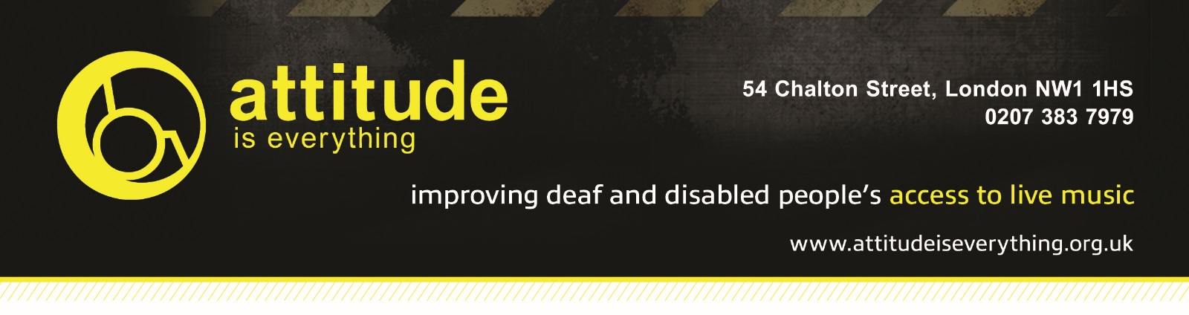

Access Starts Online – Venue Access Info Template

- Introduction
We’re committed to making performances accessible to everyone and are able to offer free carers tickets for events at The LCR and The Waterfront to patrons with disabilities. If the information you require is not listed below, then please get in touch via email on boxoffice@uea.ac.uk or by calling us on 01603 508050.

We work with Attitude is Everything specifically to improve Deaf and disabled people's access to live music by working in partnership with audiences, artists and the music industry. If you are interested in the work Attitude Is Everything does, then please visit their website to get involved or donate - www.attitudeiseverything.org.uk.

Please note we are unable to guarantee carers tickets for the other venues that we sell tickets on behalf of. Please contact that venue directly to discuss their policy.

- Contact Details
For all enquiries please contact jake.wilson@uea.ac.uk or call 01603 508050

- Venue Description
There is step free access from the car park and other drop off points to the venue box office. Once inside the venue, there is step free access to all facilities, including toilets, cloakroom and the bar.

Inside the venue, there is a lowered dancefloor which is accessible by four steps, which go around three sides. The stage forms the fourth side. There is no access to this dancefloor for wheelchair users. Across one corner of these steps is a viewing platform, located to the right of the stage.

Please let staff know upon arrival if you wish to use this platform. We will do our best to accommodate guests within your party however reserve the right to restrict access to patrons with disabilities, as this space is limited.
- Bookable Access Facilities + How To Apply (if applicable)
Deaf and disabled customers, who would be unable to attend a gig without assistance, are entitled to a free ticket for their 'Personal Assistant/Companion'.
Please purchase one standard ticket. Once you have purchased a ticket, you should then contact us on boxoffice@uea.ac.uk with your booking reference and address. We will then post you a free ticket to be used by your 'Personal Assistant/Companion'.

Please note that our staff are not trained to lift or carry people who may need help or to assist with personal or medical needs. We provide a free personal assistant ticket in order that customers with these needs may be able to attend.

- Travel Guide
There is no parking adjacent to the venue, however a convenient drop off point at the front of the building in Union Place, with step-free, slightly ramped access.
The nearest car park is the University’s main visitors' car park, which is approximately 200m (218yds) away. There are designated disabled spaces at the exit nearest to the venue. The route to the entrance from here has dropped kerbs and step-free, sloped access.
The nearest National Rail station is Norwich.
There is a bus stop within 150m (164yds) of the venue. First Buses 25 and 26 both service the UEA.

Mini cabs can be booked in advance and wait immediately adjacent to the main venue entrance for pick up.

- Arrival Guide
On the evening of an event, we offer for disabled customers to arrive at the venue 10-15 minutes prior to the doors opening to allow for early entrance. The doors opening time can vary per event, so please check in advance. Please make yourself known to Box Office or Security Staff upon arrival.
- Toilets
There is a block of gender neutral toilets located just past the Box Office on the way in to the venue. There is a disabled cubicle situated within these toilets.

- Customers with Medical Requirements
We welcome attendees to bring medicine, food or drink needed to manage a medical condition as well as medical equipment with them to our venue. We do ask that you let staff know of any medicine, equipment or needed food and drink that is on your person upon arrival. In the event of an emergency, please contact security or ask to speak to the Duty Manager on shift.

- Access to Performance
The LCR has an induction loop in our Box Office. For more information please speak to a member of staff upon arrival.

- Assistance Dogs
Guide and hearing assistance dogs are welcome, just be sure to let us know when you book.

- Strobe Lighting
Strobe lighting, lighting that produces stroboscopic effects, smoke machines and other theatrical effects may be used during shows in our venue.

- Other Info
There are lowered bars in the venue.
The LCR is part of a larger complex which has coffee shops, additional bars and shops, which are all accessible via a passenger lift and all customers are welcome to use.

